1. Go to SE11
2. Enter the name of DB Table as zXXXXXdbname

Where xxxxxx is your empcode and dbname is the name of database table.

In this case dept

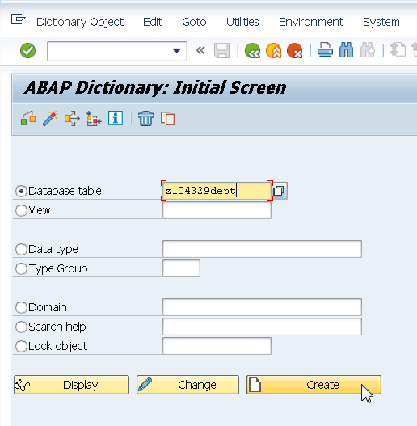

1. Enter Delivery Class and Maintenance status as shown in figure below

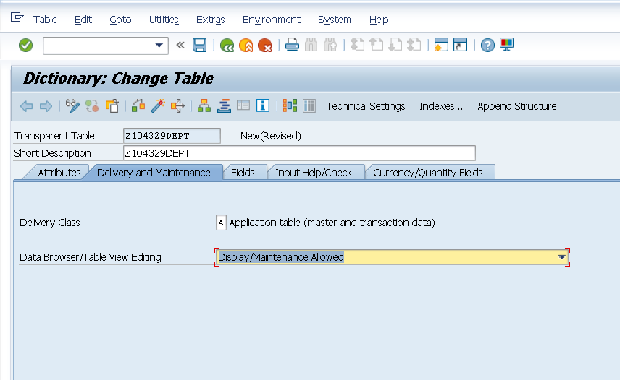

1. Go to Fields Tab. Click on Predefined Type.

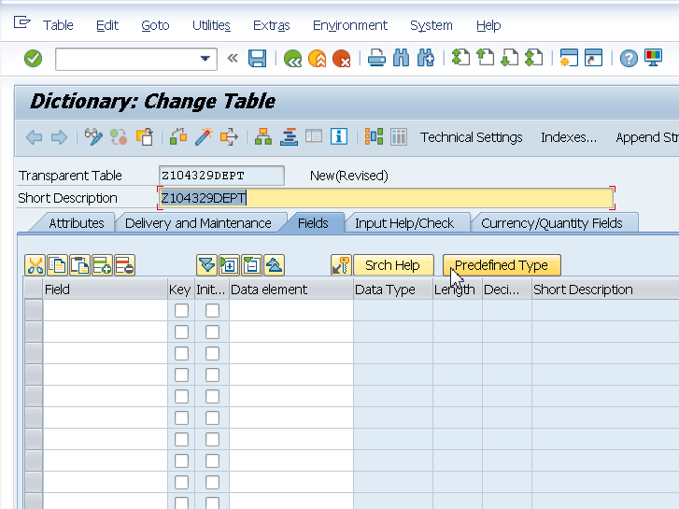

1. Enter fields and Data Type as shown below.

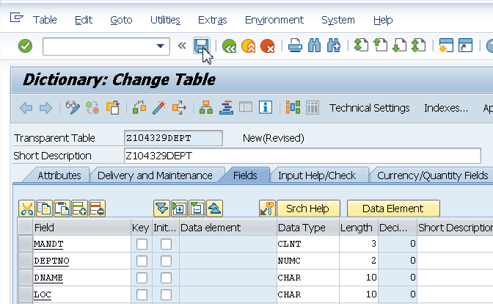

1. Save as a local object
2. Click on Technical settings

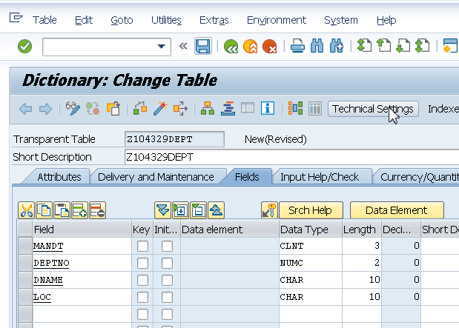

1. Enter the data class.

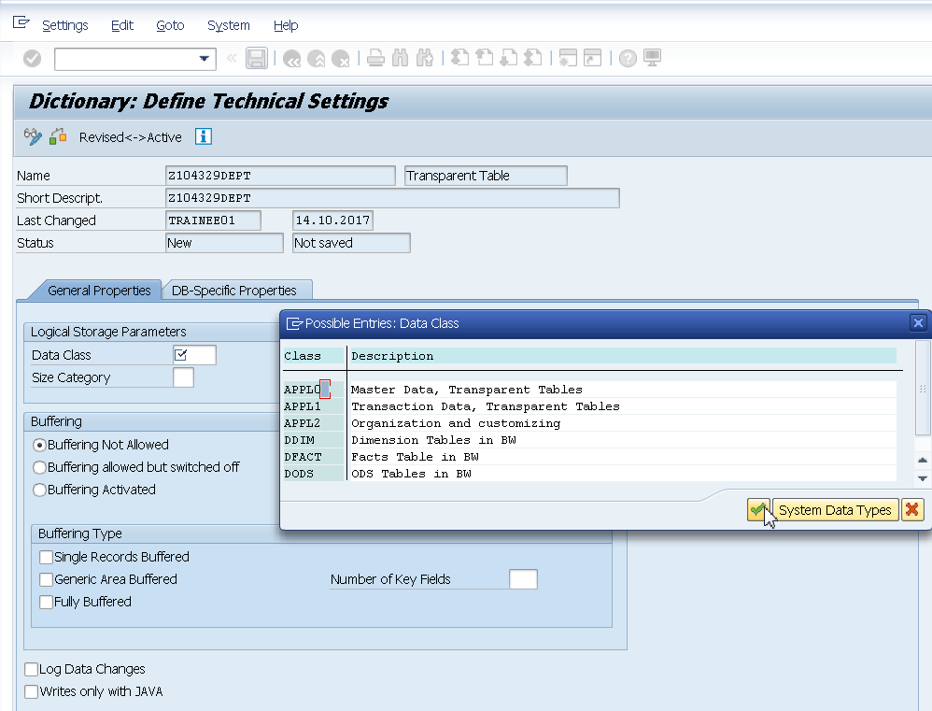

1. Enter the size category.

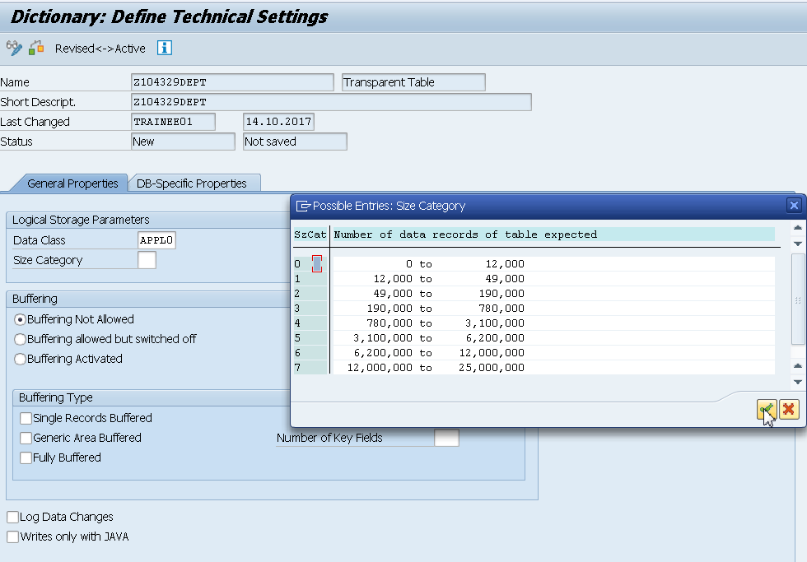

1. Click on back button.

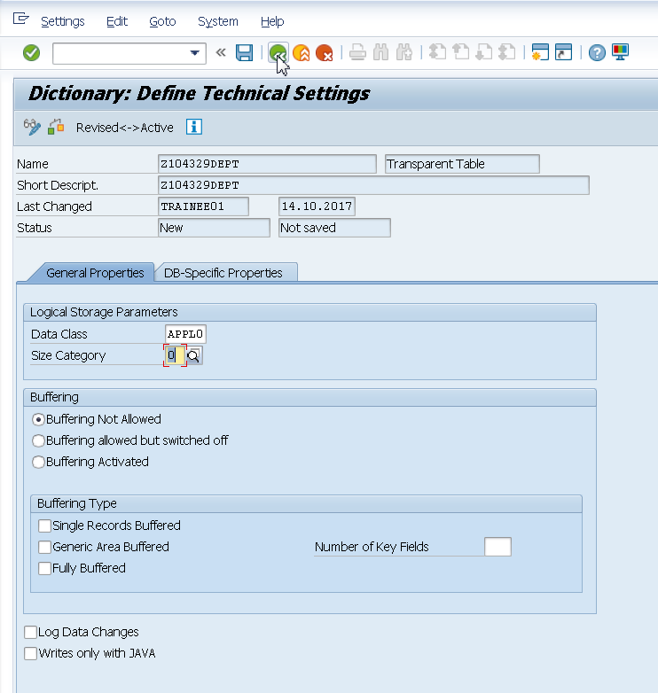

1. Specify the primary keys. Save the table.

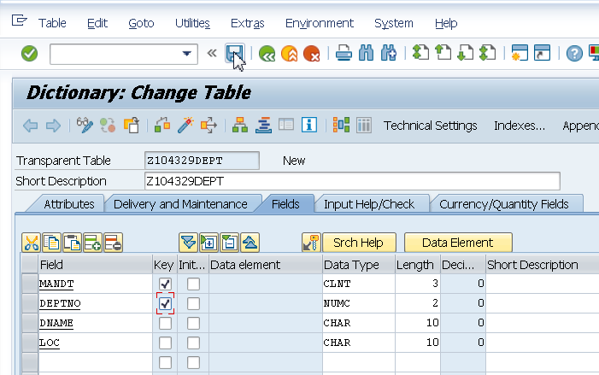

1. Activate the table.
2. Go to Utilities->Table Contents -> Create Entries
3. Enter Records in the DB Table

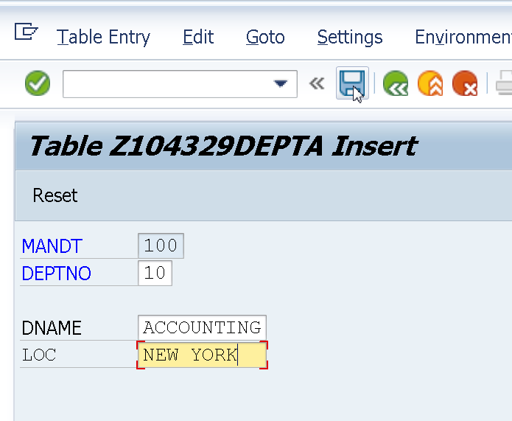

Save.

Reset.

Insert the remaining records.

20 RESEARCH DALLAS

30 SALES CHICAGO

40 OPERATIONS BOSTON'

**View the records.**

Utilities->Table Contents-Display

